Rock the Book Talk

For your Book Talk, you will create a THREE MINUTE video using your personal device (smart phone, tablet, or computer) on the book that was assigned for this three week period. The purpose of this Book Talk is to convince the viewers to read the book you are recommending. With that said, that means this Book Talk is essentially a PERSUASIVE speech, and you should employ all the persuasive techniques you know.

When you save your video, use your FIRST NAME and LAST INITIAL followed by PSATPREAP82 or PSATPREAP86.

You will have a page in this packet to organize your Book Talk. Except for the quotes you want to use, make notes so that you are not reading to your viewers—that will not end well.

You will upload you Book Talk to YouTube. The following steps will assist you in doing this:
- Open a Internet browser.
- Go to YouTube
- Select sign in
- User Name is Librarytvms@gmail.com
- The password is terravistams
- Click on upload
- Drag the video file to the screen, select private, and save

These Book Talks will be viewed by me and Ms. Davis; Book Talk videos will then be selected to be screened in the
Below are boxes of information giving you pointers on creating the video; pay close attention to them.

The Book Talk video is due on __________________________________________________.

Rock the Book Talk
Helpful Hints and Pointers

Persuasive Information:
- Rhetorical Appeals—ethos, pathos, logos (notes are in the reading and writing section of your binder as well as in the literary terms glossary)
- Rhetorical Fallacies—too many to list (literary terms glossary)
- 20 Persuasive Techniques—from alliteration to repletion and all in between (notes in the writing section of your binder)

Tips for the Video:
- Practice it a few times, recorded and not recorded.
- Be calm; just talk in your normal voice and don’t get giggly!
- Be creative with your filming background, approach, music, book use, etc. This is supposed to be FUN!
- Do NOT tell the viewers what you disliked about the book or that you chose NOT to read! This is counterproductive to the overall goal of the Book Talk, which is to get kids to WANT to read this book!
- NO SPOILERS!!!

Basic Video Requirements:
- Setting
- Main character(s)
- Conflict
- Plot
- Point of view AND perspective
- Genre—action/adventure, fantasy, science fiction, realistic fiction, historical fiction, romance, mystery/suspense, biography, autobiography
- Rating of the book 1-5 on the Book Nerd rating scale
- Explanation of rating
- Students that would enjoy this book
- Use of book as visual aid
- Persuasive techniques
See the rubric in the packet for grading expectations.

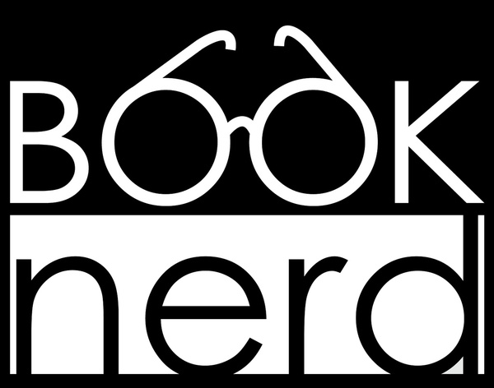
Book Nerd Rating Scale

IT WAS AMAZING! I could not put this down! I’m completely obsessed with this book and author! The characters were memorable and had distinct voices in the book. The plotline held my attention, was unique, and was paced very well. The author’s writing style was consistent, flowing writing that was engaging and enjoyable. This is definitely a book that will stay with me for a long while! HIGHLY RECOMMENDED!!!

I WOULD STAY UP ALL NIGHT TO READ! This book was really enjoyable! For the most part, there are several things I loved about this book. However, there were a couple of things that could be improved upon in the long run. This book would be really good for just about everyone! TRY IT OUT!!

IT WAS PRETTY GOOD! The book was good, overall. I didn’t love it, and I didn’t hate it—it’s kind of just there. There were some good things, but there were a few things that did bother me while reading. It was a bit slow in parts and such. I would still recommend the book; it’s just not my personal favorite. IT’S OKAY!

NEH—IT WAS ALL RIGHT. There may have been a few things that I liked about this book. This had a decent writing style, the characters were okay, and there were some things I really liked, but for one or more reasons, I had an issue with the book.

NOT WORTH OF MY BOOK NERDINESS. I did not like this book. I had several issues with the plot, characters, conflict(s), writing style, and, in general, the book as a whole. Some of the things in this book were even offensive or inappropriate to me.

Rock the Book Talk Organizer

Title: _________________________________________________________________________
Author: _______________________________________________________________________
Genre:________________________________________________________________________

Describe the Setting:

List the main characters, and provide notes describing each one:

Summary (SWBST):

List the conflict(s), and provide notes for each one:

List three of the most exciting moments with page numbers—think about the quotes:

List three reasons why others will enjoy this book:

Rock the Book Talk Rubric
Student Name: _________________________________________________________________
Title: _________________________________________________________________________
Author: _______________________________________________________________________

Book Talk Video  Element | 1  Unacceptable | 2  Acceptable | 3  Good | 4  Excellent
Content | Missing much of the required content. | Missing one or more of the required elements. | Shares all the required elements but minimally. | Thoroughly shares all required elements.
Speaks Clearly | Often mumbles or cannot be understood or mispronounces words. | Speaks clearly, distinctly but mispronounces words. | Speaks clearly, distinctly but mispronounces a couple of words. | Speaks clearly, distinctly and enunciates well.
Enthusiasm and Eye Contact | Very little use of facial expressions or body language. Did not generate interest in the viewer. | Some effort is made to show enthusiasm in facial expressions, eye contact, and body language. Minimal interest is generated in the viewer. | Facial expressions, eye contact and body language sometimes generate a strong interest in the viewer. | Facial expressions, eye contact, and body language generate a strong interest in the viewer consistently through the video.
Preparedness | Student is not prepared in the video. | Student is somewhat prepared in the video, but it is clear that practice is lacking. | Student seems pretty prepared but needed a bit more practice. | Student is completely prepared and has obviously practiced before final take.
Visual Aid | No use of the book or other visual aids. | Minimal use of the book or other visual aids. They lack deliberate purpose and lack neatness or visual appeal. | Some use of the book and other visual aids. They have some purpose and are neat and fairly appealing. | Excellent use of the book and other visual aids. They have clear purpose, are neat, extremely appealing.
Music | No use of music. | Minimal use of music. Lacks deliberate purpose. | Some use of music. Has some purpose. | Excellent use of music and has clear purpose.
Time Constraints | Under one minute | Under two minutes | Under three minutes | Three to four minutes
Column Totals

Add Column Totals Together and Divide by 7

Comments:

