Janeway’s ELAR Sophomore Contract
Classroom Behavior Expectations:
- Follow all district policies.
- Cell phones are not used during the class period without permission. They will stay in the pockets.
- Be respectful, kind, and responsible to everyone!
Any time there is a disciplinary or academic issue, parents, coaches, and/or directors will all be contacted by email.
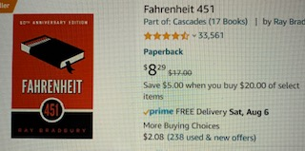
Supplies:
Students must have their laptop in every class.
- notebook paper
- pencils
- 1 ½ inch binder
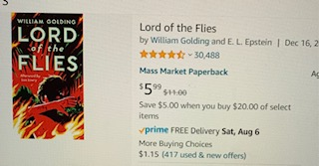
- set of 5 dividers
- the following books (prices are from Amazon):
  - Fahrenheit 451
  - The Great Gatsby
  - Night
  - The Lord of the Flies

Plagiarism, Cheating:
Plagiarism is a form of cheating that involves submitting or presenting writing or work in a class as if it is your own words or work. Plagiarism can be when the writing or work submitted is completed by someone other than the individual presenting the writing or work for a grade. Another form of plagiarism is taking information from a source without referencing the original author. The last common form of plagiarism is copying an entire source, for instance an essay, and submitting it as your own work. Scholastic dishonesty, cheating, plagiarism, or unauthorized collaboration with another person will not be tolerated.
Grading Policy:
- Corrections
  - Only SUMMATIVE ASSESSMENTS may be corrected if it is BELOW a 79 and will result in a maximum grade of 80.
  - If corrections are completed per the teacher’s instructions students may earn up to half credit back.
  - All corrections must be turned in within FIVE DAYS after the student has received the graded assessment; otherwise, it will not be accepted.
- NO extra credit is available.
- SUMMATIVE ASSESSMENTS (tests, quizzes, projects, essays) = 60%
- FORMATIVE ASSESSMENTS (everything else)= 40%
- Late work
  - Lunch detention will be assigned immediately if the work is not turned in on the due date.
  - 1 day late= -10 (start at 90), 2 days late= -20 (start at 80), 3 days= -50 (start at 50), 4+ days=0
- Absent work - The student will have ONE calendar day for each absent day to complete assignments.

Technology Expectations:
- Students may only use the applications or programs allowed by the teacher.
- Off-topic surfing the Internet is not permitted. Use of any inappropriate websites will result in direct office referral.
- Be sure your laptop is charged every night.
Students will be upheld to all the standards and requirements listed in the Acceptable Use Policy as outlined in the Shallowater ISD Student Handbook which can be found at the district website.

Classroom Library:
I have a large classroom library for the student to check out books from me. Should a book be returned damaged or lost, the student who checked out the book from me is required to replace the book with another copy. If a student or parent does not feel comfortable reading a book the student has selected, the book may be checked back in and another selected. If you have any concerns, please let me know so that we may discuss them.
Student Name _______________________________________________________

My student, ________________________________________, and I have received the school contract for this course for the 2022-2023 school year and understand the expectations for behavior and grades. Failure to comply with above expectations will result in immediate disciplinary action as well as contacting parents, coaches, and/or directors.

Please sign and return this page the next school day.

Student Signature Date

Parent/Guardian Signature Date

Mrs. Kristina Janeway Date

