How to Get to Gale Data Bases—2.0

Open Google Chrome and have TWO tabs open in this program.
In the FIRST tab…

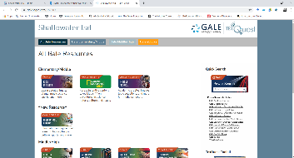
1—Type this address into the URL. https://www.galepages.com/j152909 The password is learn
2—You will see the main page below and will need to select the GALE IN CONTEXT OPPOSING VIEWPOINTS.
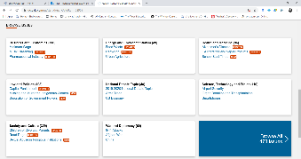
3—When you reach the next page, you will need to scroll down until you see the different categories.
4—You will need to click on your issue for research OR select BROWSE ALL 473 ISSUES.

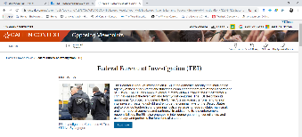
5—You will need to click on READ MORE to see the rest of the basic information.
6—Now you will need to create the citation.

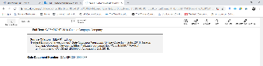
8—Scroll down to the bottom of the page to find a gray box. Copy that citation into the MLA CITATION box on you paper.

NOW, read the article and take your notes.

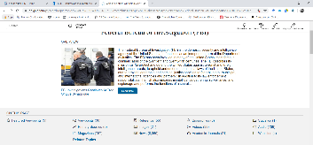
Should you need to fill in some blanks with the person you have selected, you have other resources at your disposal by clicking BACK on time and returning to the main screen for that person.

Below the initial information about the person, you will see a gray box that list the other sources available as well as the number of those sources. You may browse through them, but if you take any notes, you will need to repeat step 8 and document the citation for the source.

